**WORK-CASE №2**

1) Install a type II hypervisor on your home workstation - Virtual Box, VMWare Workstation, Hyper-V (or another one of your choice).

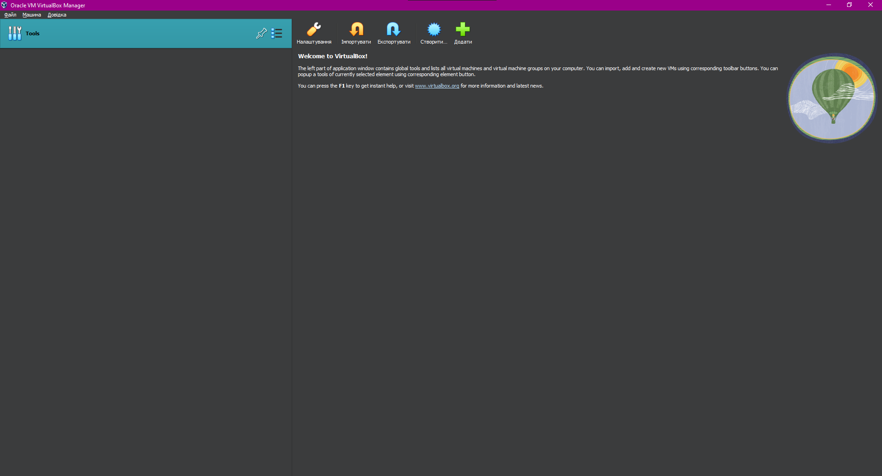

2) Describe a set of basic actions in the hypervisor you installed:

* Creation of a new virtual machine:

1. Click on the "Machine" button and then on "New" or use the key combination "ctrl + n"

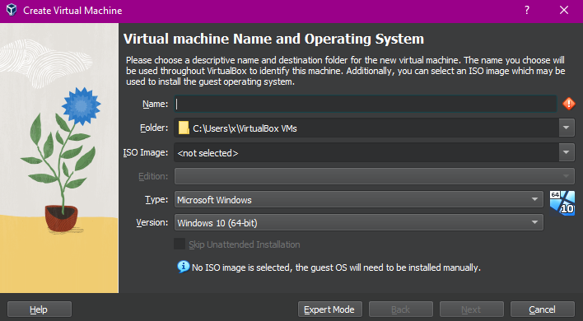

1. In this menu, we need to give a name to the virtual machine. Then we need to select the folder where we want to save the new virtual machine. Select the ISO file and choose version of OS you want to be on the virtual machine and click "Next".
2. Next you need to choose the amount of base memory and processors.
3. In the next menu u need to allocate space on the hard disk to the virtual hard disk.
4. In the end, we can see menu with all settings we have set. We need to click “Finish” and our machine will be created.

* Selecting/adding equipment available for the virtual machine:

1. First of all you need to go to the virtual machine`s settings;
2. In the settings menu, you need to click on the “USB” button, and in that menu, you can click on the “Add new USB filter” and choose the device you need.

* Network settings and connection to Wi-Fi points:

1. First of all you need to go to the virtual machine`s settings;
2. In the settings menu, you need to click on the “Network” button, and in that menu, you can set up or connect to Wi-Fi points.

* Ability to work with external media (flash memory).

If you want to connect your flash drive to your virtual machine you need to click on “Settings” of the virtual machine, go to “USB”, click on “Add new USB filter’ and choose your flash drive.

3) Install the GNU/Linux CentOS operating system (or another convenient distribution) in your hypervisor in a basic configuration with a graphical shell.

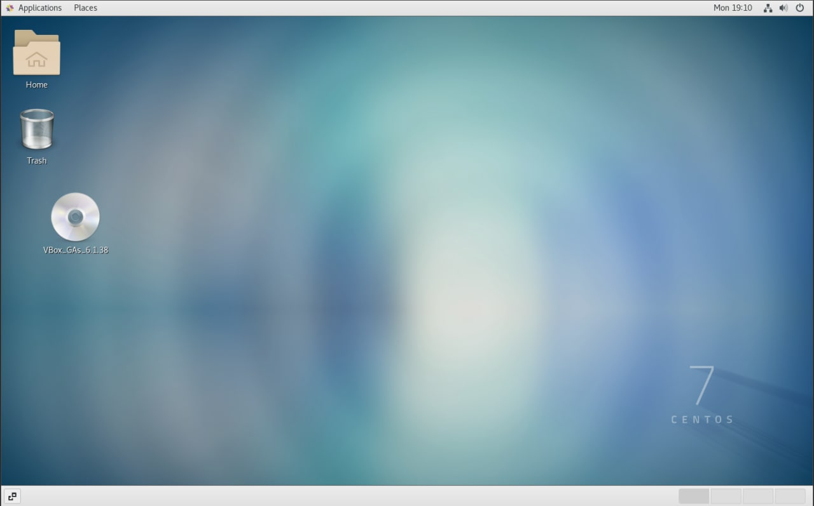

4. Create another virtual machine and do the following for it:

● Install in a minimal configuration with terminal I/O

GNU/Linux CentOS operating system without a graphical interface;

● install the GNOME desktop installed in

to the previous point of OS;

● additionally install a second graphic picture (their possible list

can be found in laboratory work #1) and compare its capabilities with

GNOME.

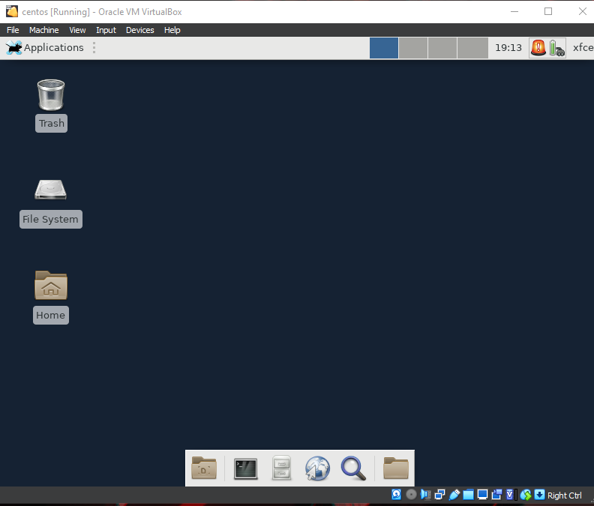

Comparison:

GNOME and Xfce are two different desktop environments for Linux and other UNIX-like operating systems. They have their own characteristics and purposes, and are chosen by users depending on their requirements and personal preferences. Here are some key differences between GNOME and Xfce:

Visual design:

GNOME: GNOME is known for its modern and elegant interface shell. It uses GNOME Shell as the core component, which includes active corners, mosaic switches and extensions to extend the functionality.

Xfce: Xfce, on the other hand, is known for its lightness and speed. It has a more classic interface, similar to a traditional taskbar.

Resource requirements:

GNOME: GNOME generally requires more computer resources, including CPU and memory. This can lead to slow performance on less powerful computers.

Xfce: Xfce is considered a lighter resource-saving environment, and it works well even on older or less powerful systems.

Extensions and customizations:

GNOME: GNOME provides less customization options compared to Xfce. It is more focused on a simplified interface for users who do not want to spend a lot of time on settings.

Xfce: Xfce is known for its flexibility and customization. You can change the look and feel of Xfce with various plugins and tweaks.

Extensions and Add-ons:

GNOME: GNOME has its own suite of applications, such as GNOME Terminal, Nautilus (a file manager), and GNOME Calendar. It also has a large number of extensions that can add new functionality.

Xfce: Xfce comes with a smaller set of built-in applications, but you can add many applications from your Linux system's repositories.

When choosing between GNOME and Xfce, it's important to consider your performance, appearance, and customization requirements. GNOME is suitable for those looking for a modern interface with less customization, while Xfce may be a better choice for users who demand ease and more control over their work environment.

Conclusion: We have installed a type II hypervisor - Virtual Box. We figured out how to install a new virtual machine and installed the operating system there. Thanks to this work, we got to know hypervisors and learned a lot about operating systems.